COVID-19
BACK TO WORK
RESOURCE PACK

Index

- Welcome
- What is the Coronavirus?
- Protecting Yourself & Others Against the Spread of Covid-19
- Covid-19 Policy Pack Summary
- Standard Operating Procedures & Checklists Summary
- Supplier Resource List
- Print Media & Usage
- Disclaimer
- Sources

Welcome
We thank you for playing an important role in our Industry’s Covid-19 readiness and for investing in this Covid-19 Resource Pack, your workspace, your staff and your customers.

Together, we can make a difference. #Covid19ready #InThisTogether

The Coronavirus & Transmission
Coronavirus disease (COVID-19) is an infectious disease caused by a newly discovered coronavirus.

Most people infected with the COVID-19 virus will experience mild to moderate respiratory illness and recover without requiring special treatment. Older people, and those with underlying medical problems like cardiovascular disease, diabetes, chronic respiratory disease, and cancer are more likely to develop serious illness.

The best way to prevent and slow down transmission is to be well informed about the COVID-19 virus, the disease it causes and how it spreads. Protect yourself and others from infection by washing your hands or using an alcohol-based rub frequently and not touching your face.

The COVID-19 virus spreads primarily through droplets of saliva or discharge from the nose when an infected person coughs or sneezes, so it’s important that you also practice respiratory etiquette (for example, by coughing into a flexed elbow).

Many people with COVID-19 experience only mild symptoms. This is particularly true in the early stages of the disease. It is possible to catch COVID-19 from someone who has just a mild cough and does not feel ill. Some reports have indicated that people with no symptoms can transmit the virus. It is not yet known how often it happens.

At this time, there are no specific vaccines or treatments for COVID-19. However, there are many ongoing clinical trials evaluating potential treatments. WHO will continue to provide updated information as soon as clinical findings become available.
Reference: https://www.who.int/health-topics/coronavirus#tab=tab_1

Protecting Yourself & Others Against the Spread of Covid-19
You can reduce your chances of being infected or spreading COVID-19 by taking some simple precautions:
What? | How? | Why?
Wash your hands frequently | Regularly and thoroughly wash your hands with soap and water for at least 20 seconds and apply an alcohol-based sanitiser. | Washing your hands with soap and water or using alcohol-based hand rub kills viruses that may be on your hands.
Avoid touching eyes, nose and mouth | Avoid touching eyes, nose and mouth to reduce risk of contamination. | Hands touch many surfaces and can pick up viruses. Once contaminated, hands can transfer the virus to your eyes, nose or mouth. From there, the virus can enter your body and can make you sick.
Maintain social distancing | Maintain at least 1-2 meters (3-6 feet) distance between yourself and anyone at all times. | When someone coughs or sneezes, they spray small liquid droplets from their nose or mouth which may contain virus. If you are too close, you can breathe in the droplets, including the COVID-19 virus if the person coughing has the disease.
Avoid going to crowded places | Crowded places mean more risk of contamination. | Where people come together in crowds, you are more likely to come into close contact with someone that has COIVD-19 and it is more difficult to maintain physical distancing.
Practice good respiratory hygiene | Make sure you, and the people around you, follow good respiratory hygiene. This means covering your mouth and nose with your bent elbow or tissue when you cough or sneeze. Then dispose of the used tissue immediately. | Droplets spread virus. By following good respiratory hygiene, you protect the people around you from viruses such as cold, flu and COVID-19.

What? | How? | Why?
If you have fever, coughing and/or difficulty breathing | If you have fever, coughing and/or difficulty breathing, seek medical care early. Stay home if you feel unwell. If you have a fever, coughing and/or difficulty breathing, seek medical attention and call in advance. Follow the directions of your local health authority. | National and local authorities will have the most up to date information on the situation in your area. Calling in advance will allow your health care provider to quickly direct you to the right health facility. This will also protect you and help prevent spread of viruses and other infections.
Stay informed and follow advice given by your healthcare provider | Stay informed on the latest developments about COVID-19. Follow advice given by your healthcare provider, your national and local public health authority on how to protect yourself and others from COVID-19. | National and local authorities will have the most up to date information on whether COVID-19 is spreading in your area. They are best placed to advise on what people in your area should be doing to protect themselves.
Reference: https://www.who.int/emergencies/diseases/novel-coronavirus- 2019/advice-for-public

Employer’s Obligations
As an employer, you have a vital role to play to ensure the well-being of your staff and your customers. All workplaces (excluding medical and health services) operating under level 4 and providing essential goods and services, need to comply with the new COVID-19 OHS Directive which applies based on an employer’s size.
To make the Directive easier to understand and apply, it has been summarised for two scenarios:
- Employers with less than 10 employees
- Employers with more than 10 employees
Further information on the Directive can be found in the “Policy Pack” document.

Covid-19 Policy Pack Summary
The Department of Employment and Labour together with the Department of Health have issued a number of regulations and directives which employers, who are permitted to operate at their relevant Alert Level, need to comply with to ensure a safe working environment. In order to assist employers with comply with these regulations, where appropriate, we have pulled together a Policy Pack which may be used to implement the necessary measures.

Not all requirements will apply to each business and the documents are generic. Each business needs to assess the risk of their workplace, based on their size and areas of risk, and amend where necessary. We have included the following documentation in the Pack:

- Policy Pack Overview
- Employer’s Responsibilities
- Summary of Covid-19 OHS Directive (Less than 10 employees)
- Summary of Covid-19 OHS Directive (More than 10 employees)
- Workplace Readiness Policy
- Workplace Readiness Plan
- Employer Responsibilities & Risk Assessment Framework
- Employee Screening Template
- Minutes of Covid-19 Meeting Template
- Authorisation Letter and Appointment Letter of Compliance Officer
- Usage of Company Vehicle/s Policy
- PPE (Personal Protection Equipment) Register
- Visitor Screening Register Template
- Covid-19 Compliance Checklist
- Disclaimer
- Sources

Should you wish to view the accompanying regulations, please click here.

Standard Operating Procedures (Covid-19 Prevention)

Standard operating procedures are written, step-by-step instructions that describe how to perform a routine activity. Employees should complete them in the exact same way every time so that a workplace can remain consistent. Standard operating procedures help maintain safety and efficiency for departments such as:

- Production/operations
- Sales and customer service
- Employee training
- Legal
- Financial
A standing operating procedure should never be difficult to read or vaguely worded. It should be brief, easy to understand and contain actions steps that are simple to follow. A good standard operating procedure should clearly outline the steps and inform the employee of any safety concerns.

The standing operating procedures should be the basis for training any new employees. They should also be updated every year to ensure they stay relevant to the current needs of a business.

In the present landscape of Covid-19, Standard Operating Procedures are more important than ever to protect employees, customers and businesses against the risk of Covid-19.

We have included a basic list of common Standard Operating Procedures, aligned to prevent the spread of Covid-19 within your business / environment.

Each SOP is a framework which needs to be customised to best fit your specific workplace requirements. At this time, it is essential that your standard SOP’s are aligned to the OHS requirements to prevent the spread of Covid-19 within your business environments.

These SOP’s and checklists are separate to this resource pack. It is important that these SOP’s are in place and your existing employees have been trained on these SOP’s prior to reopening at the appropriate lock down level.

Summary of Common SOP’s with Checklists (with Covid-19 Alignment)

- Covid-19 Safety & Sanitising System Survey
- Opening your Business (Store/Showroom/Workshop)
- Making a Customer Appointment to visit your business (Store/Showroom/Workshop)
- Making a Virtual Consultation Appointment
- Customer Care in Your Environment
- Sanitisation Processes (People / Equipment / Tools & Product)
- General Housekeeping
- Closing your Business (Store/Showroom/Workshop)

Supplier Resource Guide
There are so many suppliers selling various products to reduce Covid-19 risk. Workspace Prevention, Personal Protection Equipment, Office Sanitisation, and so on. Use this time to consider some key points, considering your work space for return:

HEALTH & SAFETY IN THE WORKPLACE
- How are you safe guarding your staff and customers against the virus?
- Are your staff trained on hygiene procedures to protect themselves and visitors during these times, including frequent handwashing?
- Is your equipment and all work surfaces wiped down regularly?
- Are your staff encouraged to closely monitor their health and do they know what to look out for in the way of Covid-19 symptoms?

CUSTOMER CARE DURING COVID-19
- Are you and staff equipped to deal with customers and visitors to your space under the new normal of contact-free?
- Do you have payment options to limit points of contact with your customers?
- Have you considered your dispatch / collection processes in limiting the risk of Covid-19 spread?

EQUIPMENT & SUPPLIES NEEDED
Do you have access to:
- Contact free thermometers to reduce the risk of Covid-19 spread?
- Hand and Surface Sanitisers
- Tissue packs for staff
- Contact free soap dispensing equipment
- Work space cleaning equipment (soaps, disinfectants)
- Protective on premises equipment including reception guards, sneeze guards, perspex screens, etc.
- Personal Protective Equipment (Face shields, gloves, masks, suits, etc)
- Personal Washable Face Masks for you and your staff which can be branded
- Deep clean / disinfecting measures for your work space
- Do you have in-store signage and information boards for your work space? Windows, Front Door, Reception, Kitchen, Bathrooms?

We have used this time during lockdown to work with identified key suppliers in securing accredited Covid-19 Care products, and collaborating with different industries to see our industry, and potential areas of risk for our trade, with fresh eyes.

We have put together a Supplier Resource Guide of vetted suppliers of Covid-19 products or services. The Supplier Resource Guide is a separate document incorporating:

SUPPLIER RESOURCE GUIDE
Protective Screens
Face Masks (Disposable)
Face Masks (Cloth)
70% Alcohol Hand Sanitisers
Face Shields
Nitrile Gloves
Non-Contact Infrared Thermometers
UV Sterilisation (Equipment & Jewellery)
Ultrasonic Cleaning (Equipment & Jewellery)
Paper Towel Dispensers
Automated Soap Dispensers
Space Disinfection

Alternatively, if you find it easier to source from one supplier, speak to us about Covid-Care packages that best suit your environment’s needs.

Print Media & Usage
Included is editable print media which can be customised and used in your workspace. Possible customising includes colour and insertion of Company Logo. These media items include:

- Front Door Sign
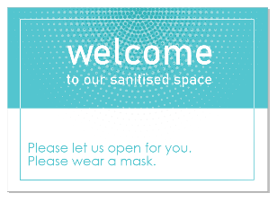
- Sneeze Screen / Reception / Till Area Sign
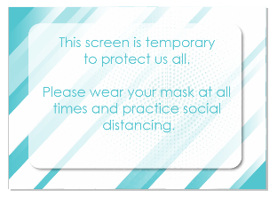
- Counter / Shelf / Foldable Tent Card
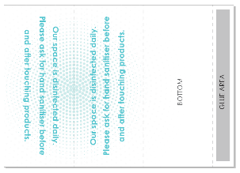

- Bathroom Counter / Basin Foldable Tent Card
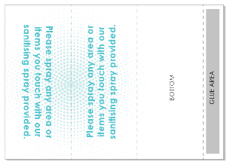
- Bathroom Counter / Basin Foldable Sign
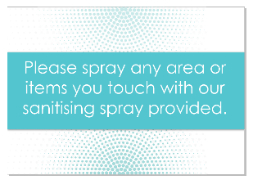
- Office / Workshop Door Signs
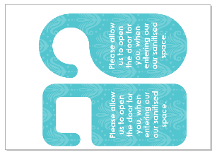

- Universal Sign
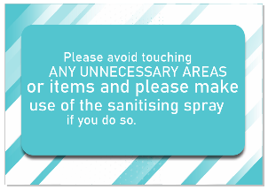
- Commitment Sign / Document for Emails / Appointment Confirmations
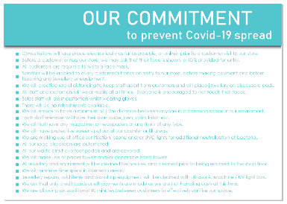
- Waste Bin Sign
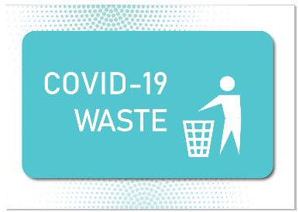

Disclaimer
The material and information in this document is made available with the understanding that we are not engaged in professional advice.

Information, including text, graphics, images and any other material in this document is provided for information purposes only, and is not a substitute for professional advice.

All recommendations in this document must be applied in taking careful consideration to each environment and the statutory requirements for said environment.

We have included external site references as courtesy. We cannot be held responsible for content or advertising provided by external sites.

